Mate if you Can!
(version 1.0, 14/01/2014)

An Augmented Reality Game for the ARIS app
(available at the itunes store)

This lab manual can be adapted to suit any individual’s need. I ask that if substantial changes are made that you decide to share with the educational community by emailing me (m.kasumovic@unsw.edu.au) a version that can be uploaded to the site and available for others.
Mate if you can! (Augmented Reality Game) by Michael Kasumovic is licensed under a Creative Commons Attribution-NonCommercial-ShareAlike 4.0 International License.

Please visit theEvolvedGamer.com for updates on this manual and for instructor manuals.

Introduction
Despite the differences between the different animals found all over the world, they all have one thing in common: mating is tough.
In sexually reproducing species, females need to find a suitable mate that provides the necessary resources for egg production, a compatible genome, a high quality territory or even proper care for their offspring.
Males, on the other hand, need to possess the traits they need to be considered attractive to females to even have a chance at mating. In addition, they also need to ensure they possess traits that allow them to outcompete rivals for access to females. Very often, these traits are not the same.
The aim of this lab is to demonstrate the affect juvenile life-history decisions have on adult male mating strategies and mating success.
In this lab, each team of four will play the role of a single male trying to outcompete their fellow classmates to secure the most matings they can. Before the game starts, however, each team will be required to make two developmental decisions that will determine the traits they will possess at maturity, and therefore, the mating strategies they will need to use.
Before we start, let’s quickly revisit resource allocation theory.

Life-history trade-offs
Life-history trade-offs are a fundamental part of individual development. Due to foraging restrictions by predators and/or limited food availability, individuals are limited in the resources they have while developing. As a result, individuals must choose which traits they need to allocate resources to maximize fitness. When allocating resources towards one trait, it results in fewer resources available for other traits which means that they are expressed at a relatively lower level.
Although these developmental choices often happen before maturity, they can have important consequences on how individuals look and behave after maturity.

How we’ll play
In this lab, we will use a location based app on iOS to navigate a world filled with food, females, and predators. In a sense, you and your colleagues will play a scavenger hunt while using your iPad/iPhone. Your team of four will play the role of a mate searching male (specifically a male peacock spider, Maratus volans).
Prior to beginning the experiment, each group will need to make two developmental decisions:
(1) Do you develop quickly and mature small or hold off on maturing so you can gain resource to mature larger, and
(2) do you invest in a physiological system that allows you to respond rapidly to varying situations but requires more energy, or one that minimizes energy use but results in slower responses.

After making these choices, you will have to navigate through campus to search for females and avoid predators. This experiment will provide you with an idea of the different challenges males have while searching for mates and will require you to find the best strategy to maximize fitness.

Preparation
You will be working in groups of four. You will need one iPad/iPhone per group. You will need to download the ‘ARIS’ app from the iTunes store. You should also have a notebook to write down information as you gather it.
Materials:
Each group of students will require:
1. The lab book or a notebook for talking notes.
2. An iPhone with the ARIS app (https://itunes.apple.com/au/app/aris/id371788434?mt=8)
3. Create a player account using the ARIS app.
4. Comfortable shoes. You will be walking, and maybe even running!

The Aris App
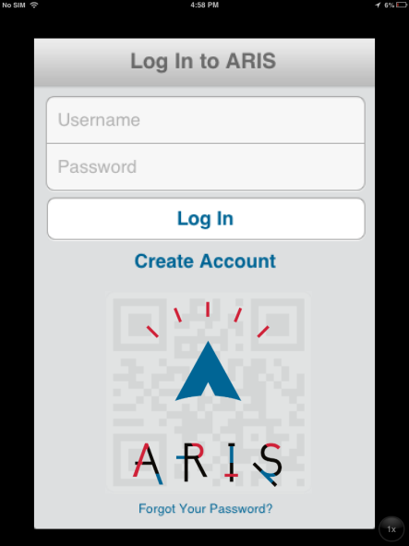
The first thing you see when you launch ARIS is a login screen. In order to log in you need to create an account.
N.B. - create a user name and password that are easy to type in on an iphone. Security is much less of a concern here than with other things (e.g. your gmail account).
Server URL - http://arisgames.org/server - This is the server that the client points to automatically. If you create games on the editor, they are on this server. It is possible to create another server and point ARIS at that server.
Show Games in Devel (on/off) - Turning this to on will reveal the game we will be playing: “Mate if you can!”

.

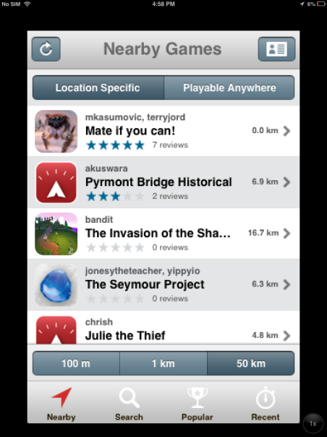
Game Picker
When you first login to ARIS you will be in the game picker. You will select a game using “Nearby” Search for the game called “Mate if you can!”. If you cannot find it using the “Nearby” function, you can search for the game in the “Search” function.

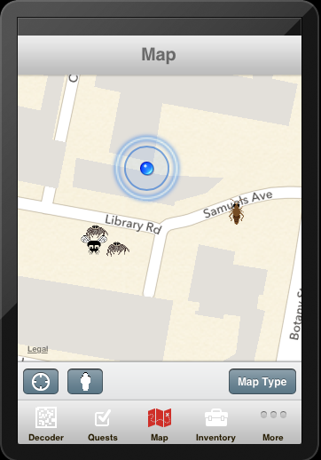
Map - This will be the main game interface. It’s basically a google map with some extra information and interactivity.
The blue dot - That’s where you are (or where your device thinks you are).
N.B. The circle of confusion around the blue dot is an iOS feature that does not interact with ARIS. This can be confusing.
ARIS locations - These icons represent in-game content. Once you get close enough, they will show up in the nearby tab or take over the screen entirely, depending on whether auto display is set. Typically, a large part of playing ARIS games involves the players using the Map to get to these physical locations.

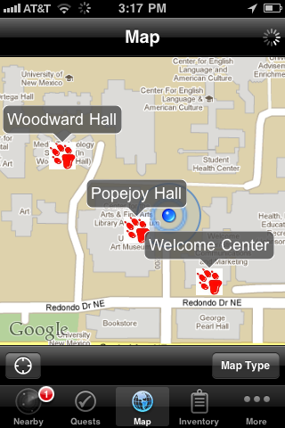
Nearby
This tab, unlike the others, only appears in the tab bar when there are nearby accessible locations in the ARIS game you are playing.
In the screenshot above, the map tab is active, the player is near a game object, and so the nearby tab becomes visible (bottom left).
The nearby tab shows a list of all the nearby locations available to the player.

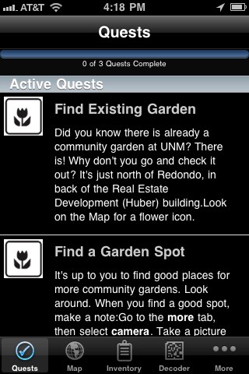
Quests
Quests can give a player information about what to do next, and what they’ve already accomplished. We will use the quests to keep track of how many times you have mated.

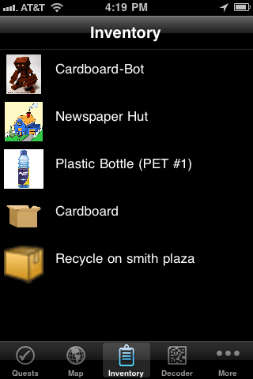
Inventory
This tab shows the player’s inventory, all the items the player currently has. Items can be picked up off the map, given to a player by characters in the game, and created by the player via the camera and recorder.

We will not be using any of the recording, camera, Scanning or note taking features of the App.

Starting the game
After you start the app, move to the front entrance of the Biosciences Building. When you reach the entrance, you will be prompted to open a plaque entitled “Game Start”. Opening the plaque will provide you with the details of the game:

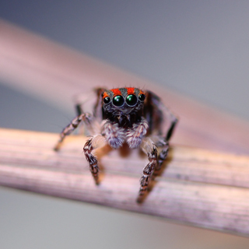
You are a male spider about to mature. To pass on your genes to the next generation, you must successfully find and mate with a female.
Before you begin, you need to make some developmental decisions; each has its benefits and costs.
Choose wisely and good luck!

After closing the plaque, you will be prompted to open another plaque titled “Development Strategy”. This will describe the first of the decision you will have to make:

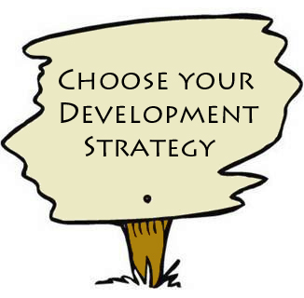
After reading this, two new plaques will appear to offer a developmental choice.
You can either:
-Mature early to begin searching for females (but you'll be smaller) or
-Mature later so that you can mature larger (but you'll mature later in the breeding season).
Only view the plaque that you want to choose! The other plaque will disappear.

IMPORTANT: After closing the plaque, you will have to choose one of the two available plaques that appear:
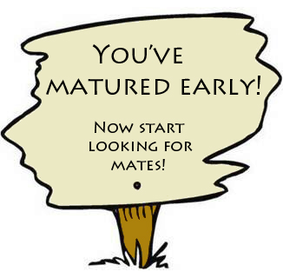

ONLY READ THE ONE YOU WANT TO CHOOSE. You will not get a second choice, and the other will disappear.
You will then need to make a second developmental decision regarding your physiology which will appear on another plaque titled “Physiology Makeover”.

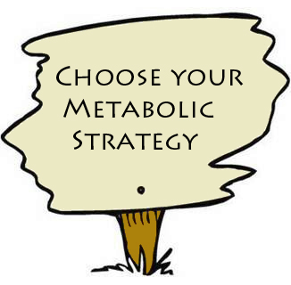
After reading this, two new plaques will appear to offer a developmental choice.
You can either have:
-Higher metabolic rate which will allow you to ramp up energy production when necessary (but it uses more energy) or
-Lower metabolic rate which saves energy (but may put you at risk in dangerous situations).
Only view the plaque that you want to choose! The other plaque will disappear.

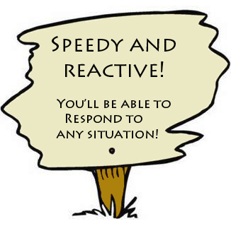

Again, you will only be able to read one of the plaques, so make sure you choose the one you want.

While each team is setting up their IPad, discuss with one another the developmental decisions you will make.
1. Will you:
- Mature early
or
- Mature late
What traits do you think your male will possess as a consequence? How will he look?
____________________________________________________________________
____________________________________________________________________
____________________________________________________________________
____________________________________________________________________
What will your male be good at? Will he be able to outcompete rivals? Be more attractive to females? Explain why you think so.
____________________________________________________________________
____________________________________________________________________
____________________________________________________________________
____________________________________________________________________

2. Will you:
- Invest in a high metabolic rate
or
- Energy saving metabolic rate
What consequence do you think investing in your physiology has? How will males that invest in a high metabolic rate differ from those that invest in a low metabolic rate?
____________________________________________________________________
____________________________________________________________________
____________________________________________________________________
____________________________________________________________________

What do you think your male will be good at as a consequence of your decision?
____________________________________________________________________
____________________________________________________________________
____________________________________________________________________
____________________________________________________________________

3. Your combination of traits (decisions made in 1 + 2) will produce a specific phenotype (e.g., a late maturing male with a high metabolic rate).
What strategy will you male have to follow to have the greatest mating success?
____________________________________________________________________
____________________________________________________________________
____________________________________________________________________

Which females will you target?
____________________________________________________________________
____________________________________________________________________
____________________________________________________________________

What behaviours do you think your male will perform poorly? What will you try to avoid doing as a consequence?
____________________________________________________________________
____________________________________________________________________
____________________________________________________________________

Beginning the game
Once you make both of your developmental decisions, you can begin the game and start searching for females.
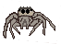
Females will begin spawning on your map around the university. You will be able to see them as a small image of a spider. You will be able to interact with these females when you get close enough. When interacting, follow the prompts on your screen to make different decisions in an attempt to mate.

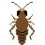
Food in the form of flies and crickets will also appear around the university. You will need to collect these for energy. Everything from courting to avoiding predators costs energy.

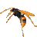
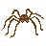
Predators in the form of wasps and wolf spiders will also spawn, but you will NOT be able to see them on the map. Certain areas will contain more of each predator type. You will have to find out what they are.

IMPORTANT: While playing the game, food and females will spawn off of campus DO NOT LEAVE UNIVERSITY PROPERTY! In addition, food and females may spawn in places that cannot be reached (such as inside buildings), AVOID THESE SPAWNED INSTANCES! There will be plenty of other females and food instances to find.
Spawned instances of food, females, and predators will only remain either until someone reaches the location, or until 100 seconds has passed. This simulates competition for resources and the progression of the breeding season.
Your goal will be to mate with as many females as you can while dying as little as possible. Each of your success and failures will be recorded by the game as “attributes”. Once you return to class, we will post everyone’s successes and failures and examine how everyone performed.
Follow the strategies that you discussed with your team and see how you perform.
You can all run together as a team, or take turns being the mating male. Just make sure you discuss how you’re doing with your teammates to see if you need to alter your strategy and how you should do so. Remember, all your classmates are your competitors!
Good luck!

Back in the Laboratory
After everyone has finished mating and dying, we will return to the lab to examine how everyone performed (mating successes and failures).
Each group will place the number of successful matings, the number of deaths by various things, as well as other measures of failure and success and we will discuss the different strategies individuals used and how well each of the strategies worked for the different life-history decisions that the different groups made.

Which mating decisions did you make?
Development strategy:____________________________________________________
Metabolic Strategy: ______________________________________________________

Do you feel you used the right strategies for your decisions? How could you have performed better?
____________________________________________________________________
____________________________________________________________________
____________________________________________________________________

What did your male excel at doing? Were your predictions correct?
____________________________________________________________________
____________________________________________________________________
____________________________________________________________________

What were the limitations of your developmental decisions? Were you prepared for these limitations? Or did you discover new limitations?
____________________________________________________________________
____________________________________________________________________
____________________________________________________________________

Given what you’velearned from the effect mating decisions have on adult phenotypes and mating strategies, answer the following questions:

Do you think there was one ultimate strategy? Why or why not?
____________________________________________________________________
____________________________________________________________________
____________________________________________________________________

Do you think this laboratory was realistic in that males in nature can experience similar types of challenges?
____________________________________________________________________
____________________________________________________________________
____________________________________________________________________

When do you think a rapid development strategy would be favoured in nature? How do you think this would affect the phenotypes in the population?
____________________________________________________________________
____________________________________________________________________
____________________________________________________________________

How about a slow developing strategy?
____________________________________________________________________
____________________________________________________________________
____________________________________________________________________

Was having an appropriate metabolic rate important in this lab?
____________________________________________________________________
____________________________________________________________________
____________________________________________________________________

Can you think of some instances where different metabolic rates would be favoured in different circumstances? Use any animal examples that you can think of (that includes humans!)
____________________________________________________________________
____________________________________________________________________
____________________________________________________________________

What did you learn about male mating strategies and how males perform?
____________________________________________________________________
____________________________________________________________________
____________________________________________________________________

