Gift Giving & Taking
(version 1.0, 30/01/2014)

An Augmented Reality Game for the ARIS app
(available at the itunes store)

This lab manual can be adapted to suit any individual’s need. I ask that if substantial changes are made that you decide to share with the educational community by emailing me (m.kasumovic@unsw.edu.au) a version that can be uploaded to the site and available for others.

Gift Giving & Taking (Augmented Reality Game) by Michael Kasumovic is licensed under a Creative Commons Attribution-NonCommercial-ShareAlike 4.0 International License.

Please visit http://theEvolvedGamer.com for updates on this manual and for instructor manuals.

Introduction
Reproducing is costly.
Females encounter numerous different costs that range from finding and selecting preferred males while rebuking harassing males. The most substantial costs that females pay, however, is in offspring production and rearing due to the relatively larger and more energy expensive gametes females produce and the rare investment that males provide in parental care.
Although males do not pay the same costs associated with gamete production, males still pay substantial costs for successful reproduction. Males need to develop traits that ensure competitive success while simultaneously being attractive to females. Males also spend a large number of time and resources in trying to either find or attract females.
Because the cost of reproduction is so high for each sex, both males and females attempt to minimize the costs they would pay for successful reproduction. This, however, results in greater costs being borne by the opposite sex, inevitably leading to conflict over who should pay the greatest costs. This is the underlying idea of Sexual conflict.
In this lab, we will explore the subtleties of sexual conflict. The aim of this lab is to understand how small benefits for one sex can result in large inequalities for the other. We will explore how quickly inequalities can arise and quickly they are balanced out by the opposite sex.
In this lab, each team of two will play the role of either a male or female gift-giving dance fly (Rhamphomyia sulcata). Males of this species catch food items which they offer to females as gifts. If the female accepts the gift, males are allowed the opportunity to copulate. So in essence, males are trading a gift for a copulation.
The goal of the game will differ for the sexes: students playing the male role will try to collect as many matings from classmates playing the female role, while students playing the female role will try to produce as many egg clutches as possible.
The team with the most matings or egg clutches wins!

How we’ll play
In this lab, we will use a location based app on iOS to navigate a world filled with food, pheromones and gifts. In a sense, you and your colleagues will play a scavenger hunt while using your iPad/iPhone. The game we will play is “Gift Giving & Taking”.
Prior to beginning the experiment, you will need to decide who your partner will be. Then together, you will need to decide whether you will play the male or female role. Your demonstrators will ensure the teams are equal. (But what would happen if they weren’t? Think about this as we’ll come back to this question at the end.)
After making these choices, males will have to navigate through campus to search for food to create gifts, and then find females to offer their gifts to. Females will need to lay down pheromone trails to allow males to find them and use the gifts collected to create either egg clutches or more pheromones. This game will provide you with an idea of the different challenges males and females encounter while mating. In addition, it will require you to find the best strategy to maximize fitness.

Preparation
You will be working in groups of two. You will need one iPad/iPhone per group. iPads can be provided to your team by temporarily trading your student ID and phone (both will be kept very safe!). If you would rather use your own iPad/iPhone, you will need to download the ‘ARIS’ app from the iTunes store (search arisgames under phone apps).
Materials:
Each group of students will require:
1. The lab book or a notebook for talking notes.
2. An iPhone with the ARIS app (https://itunes.apple.com/au/app/aris/id371788434?mt=8)
3. Create a player account using the ARIS app.
4. Comfortable shoes. You will be walking, and maybe even running!

The Aris App
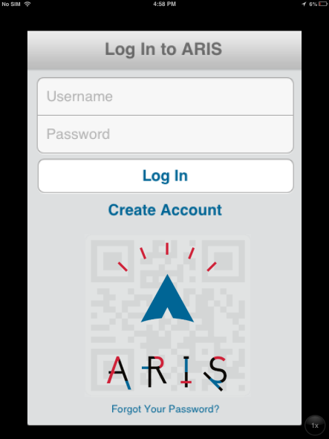

The first thing you see when you launch ARIS is a login screen. In order to log in you need to create an account.
N.B. - create a user name and password that are easy to type in on an iphone. Security is much less of a concern here than with other things (e.g. your gmail account).

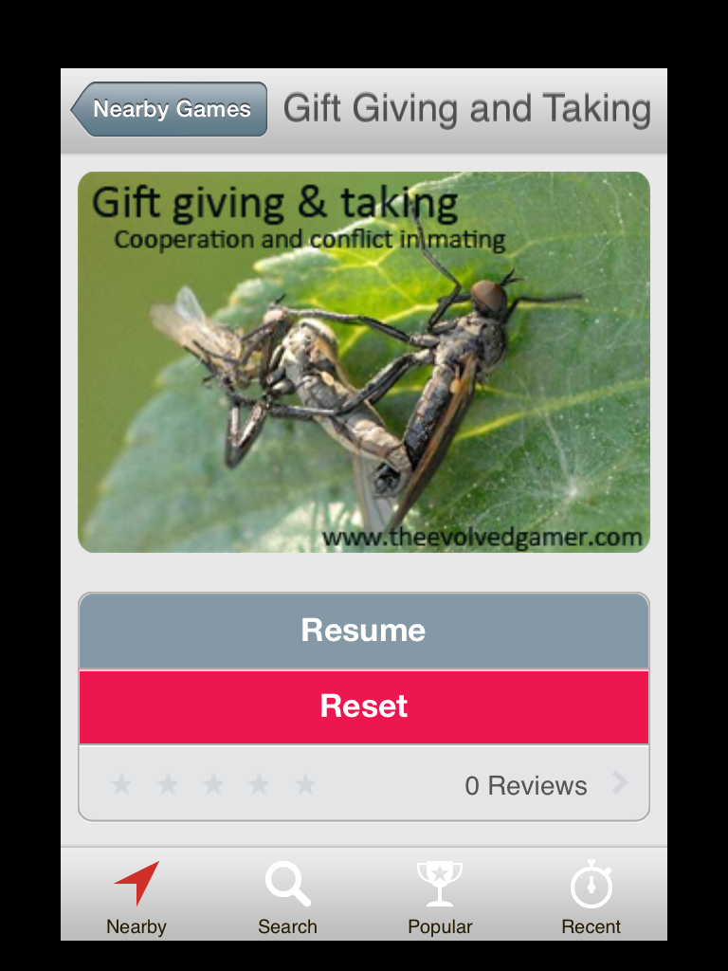

Once logged in, your game will be saved even if the app force closes. You can continue where you left off.

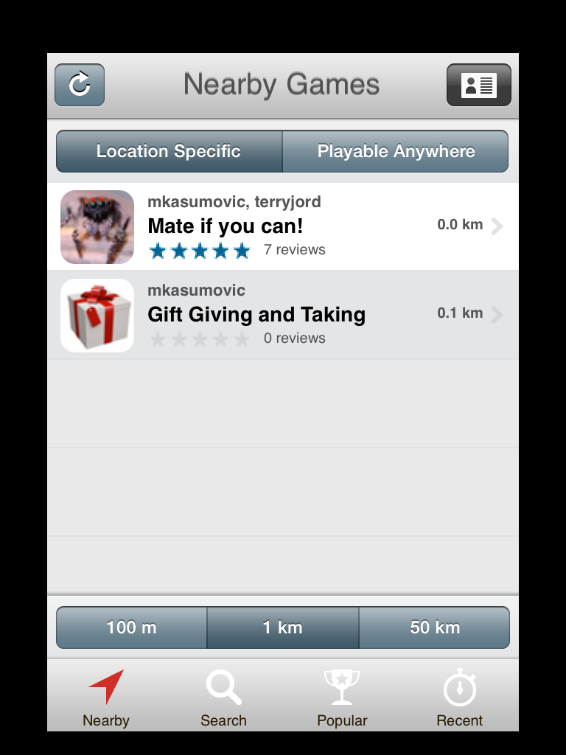
Game Picker
When you first login to ARIS you will be in the game picker. You will select a game using “Nearby” Search for the game called “Gift Giving & Taking”.
If you cannot find it using the “Nearby” function, you can search for the game in the “Search” function.

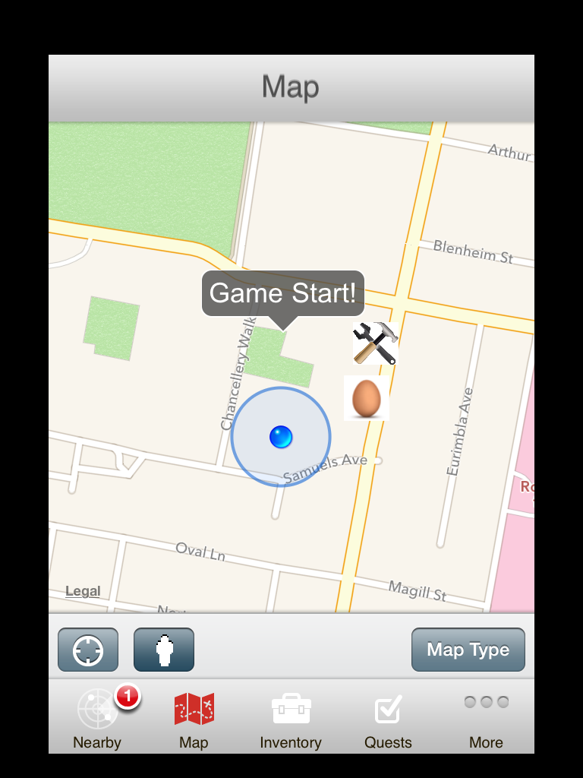Map - This will be the main game interface. It’s basically a google map with some extra information and interactivity.
The blue dot - That’s where you are (or where your device thinks you are).
N.B. The circle of confusion around the blue dot is an iOS feature that does not interact with ARIS. This can be confusing.
ARIS locations - These icons represent in-game content. Once you get close enough, they will show up in the nearby tab or take over the screen entirely, depending on whether auto display is set. Typically, a large part of playing ARIS games involves the players using the Map to get to these locations.
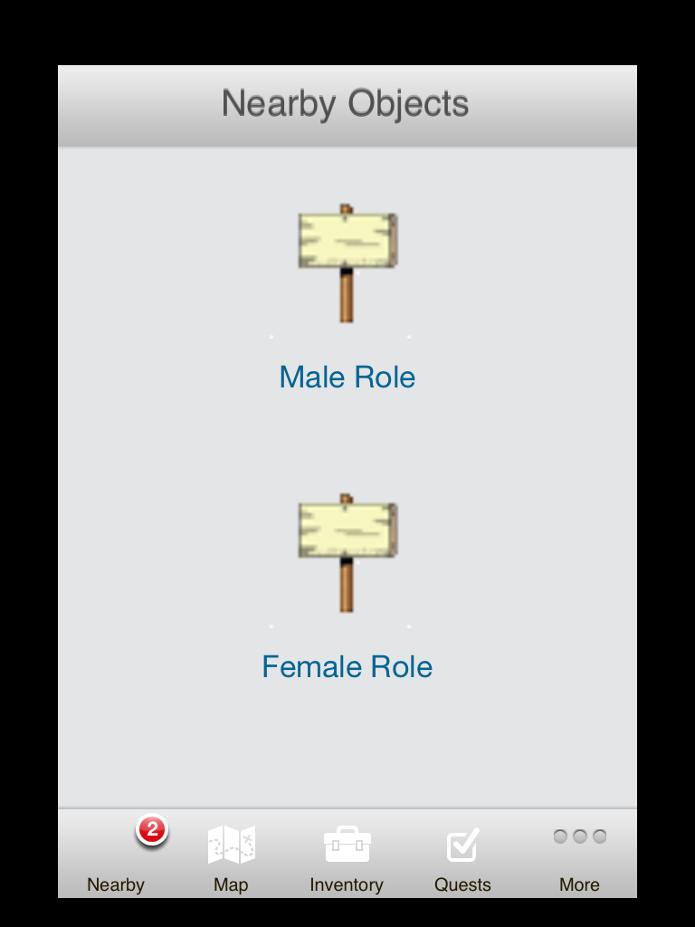
Nearby
This tab, unlike the others, only appears in the tab bar when there are nearby accessible locations in the ARIS game you are playing.
In the screenshot above, the map tab is active, the player is near a game object, and so the nearby tab becomes visible (bottom left).
The nearby tab shows a list of all the nearby locations available to the player. Plaques to make decisions can easily be accessed here.

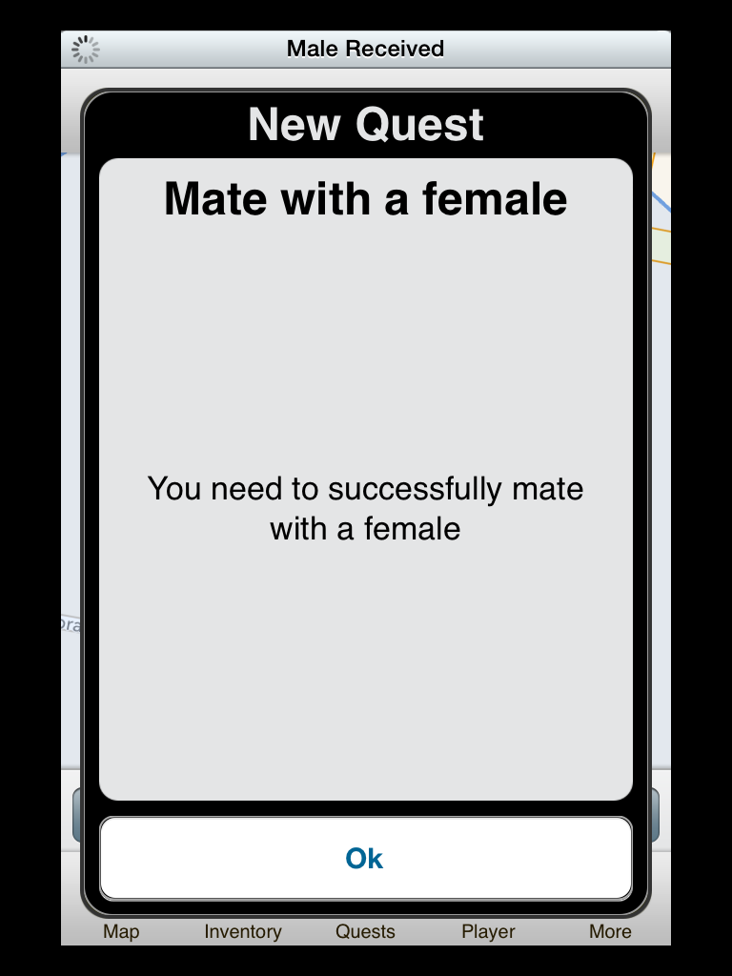
Quests
Quests give players information about what to do next, and what they’ve already accomplished.
Quests will pop up as you progress through the game offering suggestions and rewarding you for your performance.
There is also a quest tab, which will provide you details on the quests you have available and those that were completed.

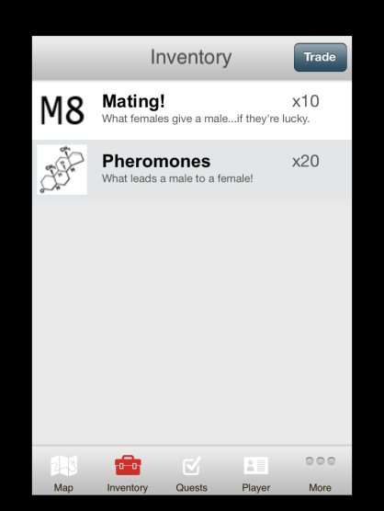
Inventory
The inventory is where your collected items will be stored. This is the screen you will use to ‘trade’ items.
The trade function does not work.
You can trade items by dropping them on the ground so your trading partner can pick them up.

We will not be using any of the recording, camera, Scanning or note taking features of the App.

Starting the game
After you start the app, move to the front entrance of the Biosciences Building. When you reach the entrance, you will be prompted to open a plaque entitled “Game Start”. Opening the plaque will provide you with the details of the game:
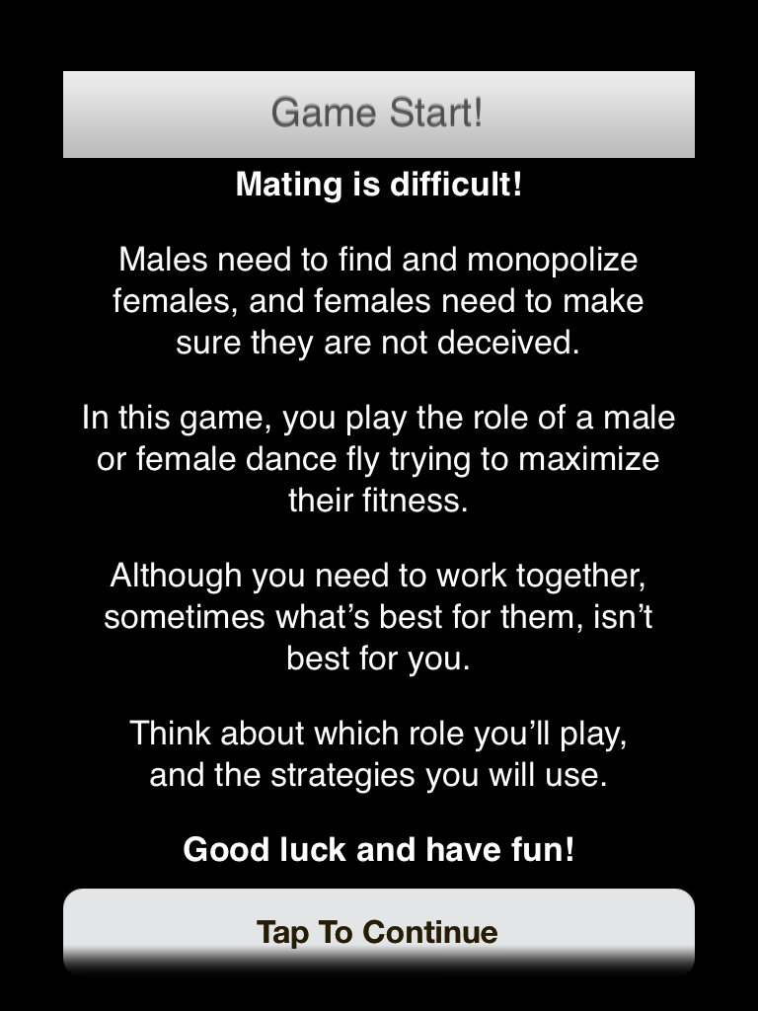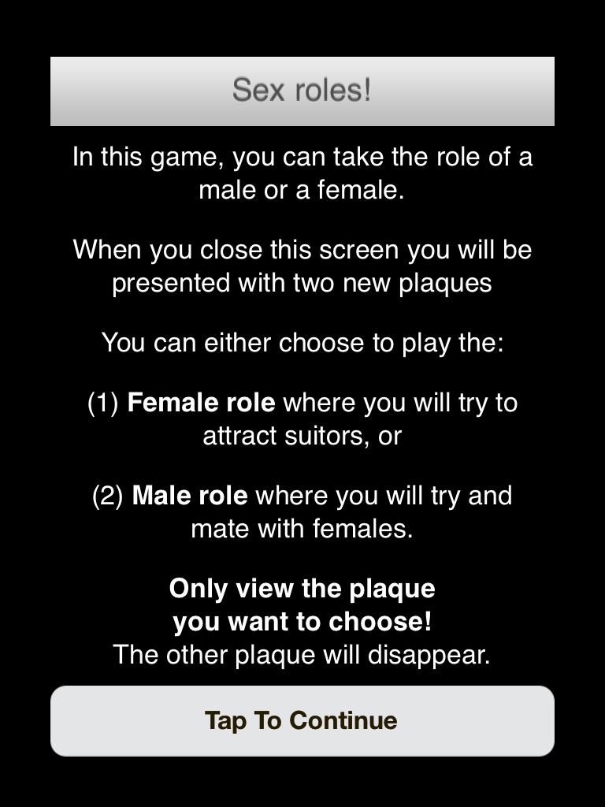

These plaques will outline the purpose of the game.
After closing each subsequent plaque, you will need to choose whether you will play the male or the female role. Decide with your partner which role you’d like to play. The demonstrators will ensure the number of male and female roles are approximately equal before everyone chooses.
When choosing, only choose the plaque of the role you want to play! The other plaque will disappear.

Players choosing the male role will be able to begin playing immediately.
Players choosing the female role will need to view one more plaque. Before doing so, each female team will be assigned an ID between 1 and 15 while in the lab. When viewing the ’Female Start’ plaque make sure you choose the plaque according to your ID!
This will ensure we can keep track of who mates with whom.

1. Will you choose:
- The male role
or
- The female role

2. What is your goal while playing this role?
____________________________________________________________________
____________________________________________________________________

You are now ready to play!
Males
You start collecting flies to make gifts. Gifts can be made at the Gift Maker. You can access the Gift Maker from anywhere by tapping on the icon on the map. Then follow the choices to create what you want. You can trade females your gifts for a mating.
Females
You will need to settle outside the red area and lead males to where you are by using pheromones. The matings you were given at the start can be traded for nuptial gifts from males. You will be able to trade these gifts at the Egg & Pheromone Maker to create either egg clutches, or more pheromones to try and attract more mates.
You’ll also be able to catch some flies to use to create pheromones and egg clutches, but they appear rarely. You will need to decide how to best use your time.

As you play, you will be offered clues and strategies through quests that you can choose to follow. They may or may not lead to greater fitness.
You can all run together as a team, or take turns and then head back to your teammate to discuss ideas.

Remember: The only way to win is to ensure you are selfish - all your classmates are your competitors! You have 30 minutes. Good Luck!

Questions:
While each team is setting up their IPad, discuss the strategies you will use.
Females:
1. Pheromones are costly. You get 20 to start with, but how can you minimize their use and maximize their effect?
____________________________________________________________________
____________________________________________________________________
____________________________________________________________________
____________________________________________________________________

2. How will you attract the most males? What will your male be good at? Will he be able to outcompete rivals? Be more attractive to males? Explain why you think so.
____________________________________________________________________
____________________________________________________________________
____________________________________________________________________
____________________________________________________________________

3. Think of three ways you can take advantage of males. Which of the three ways is most likely to work? Explain why you think so.
____________________________________________________________________
____________________________________________________________________
____________________________________________________________________
____________________________________________________________________

Males:
1. Creating gifts is costly. Can you think of ways to minimize these costs?
____________________________________________________________________
____________________________________________________________________
____________________________________________________________________
2. You will need to outcompete rivals and also convince females to mate. Which do you think will be more difficult? Why? Explain.
____________________________________________________________________
____________________________________________________________________
____________________________________________________________________
____________________________________________________________________

3. Think of three ways you can take advantage of females. Which of the three ways is most likely to work? Explain why you think so.
____________________________________________________________________
____________________________________________________________________
____________________________________________________________________
____________________________________________________________________

Icons
Items
Items are simply things that can be picked up and traded. There are 3 different items in the game.
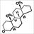
Pheromones: This is what females will drop on the ground to create trails for males to follow.

Matings: This is the item that females will trade for gifts from males. Each mating will have a female’s ID

Gifts: This is what males will create from collecting flies and will trade for matings from females.

Characters
Characters are things that can be interacted with in the game. Some will offer you choices.
Egg & Pheromone Maker: This is character that females will interact with to trade their gifts in to make either egg clutches or more pheromones. This character can be interacted with form anywhere simply by touching the icon on the map.

Gift Maker: This is character thatmales will interact with to create gifts from the flies that they catch. This character can be interacted with form anywhere simply by touching the icon on the map.

Fly: Food in the form of flies which will appear in designated areas around upper campus. You will need to collect these to create objects with. Spawned instances of food will only remain either until someone reaches the location, or until 100 seconds has passed. This simulates competition for resources

IMPORTANT: While playing the game, DO NOT LEAVE UNIVERSITY PROPERTY!

Back in the Laboratory
After everyone has finished mating, cheating and lying, we will return to the lab to examine how everyone performed.
Each group will place their fitness on the board as well as the various types of effort (e.g., # gifts or pheromones created). We will then discuss which individuals performed the best, the strategies they used, and what did and didn’t work.

- Which Sex did you play?
Male Female

- What tactics did you use to attract or find the most mates?
____________________________________________________________________
____________________________________________________________________
____________________________________________________________________
____________________________________________________________________

- Do you think this was the most viable strategy? Explain.
____________________________________________________________________
____________________________________________________________________
____________________________________________________________________
____________________________________________________________________

- Was there a way for you to increase your fitness? What would you have done differently in that case?
____________________________________________________________________
____________________________________________________________________
____________________________________________________________________
____________________________________________________________________

- Did your attempt to take advantage of the opposite sex work? If yes, why do you think so? If not, what would have worked better?
____________________________________________________________________
____________________________________________________________________
____________________________________________________________________
____________________________________________________________________
____________________________________________________________________

- Do you think this laboratory was realistic in how selection functions? Why or why not?
____________________________________________________________________
____________________________________________________________________
____________________________________________________________________
____________________________________________________________________

- Are there aspects in this game that could be improved? For example, could this game be made more realistic?
____________________________________________________________________
____________________________________________________________________
____________________________________________________________________
____________________________________________________________________
____________________________________________________________________

- What strategies would you have used if you were the opposite sex?
____________________________________________________________________
____________________________________________________________________
____________________________________________________________________
____________________________________________________________________
____________________________________________________________________

